|  |  |  |  |  |  |  |
| --- | --- | --- | --- | --- | --- | --- |
|  | Bat Action Time! - Lesebegleiter |  |  |  |  |  |
|  |  | | | | | |

Bat Action Time! - Lesebegleiter

von Ronja Wienewski

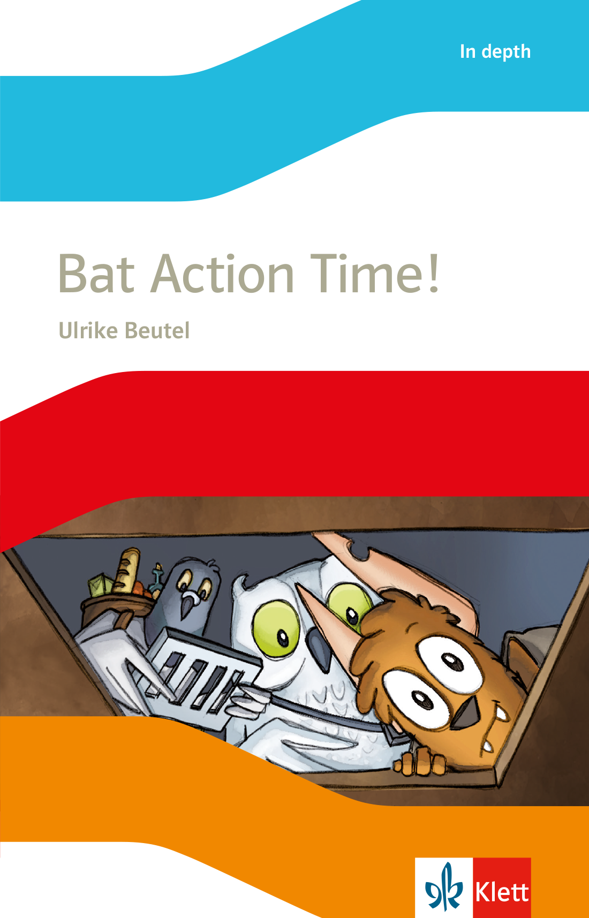

Dieses Material kann sowohl im Unterricht als auch zu Hause eingesetzt werden. Es begleitet die Schülerinnen und Schüler von Kapitel zu Kapitel und unterstützt sie mit abwechslungsreichen Aufgaben beim Erschließen des Texts. Zahlreiche kreative Aufgaben bieten einen alternativen Zugang zum Text und motivieren die Schülerinnen und Schüler, über den Inhalt nachzudenken.

Die Lösungen zu allen Aufgaben können von den Schülerinnen und Schülern zur Selbstkontrolle verwendet werden.

Inhalt:

Kopiervorlage  1: Before you read

Kopiervorlage  2: Ben and his friends I

Kopiervorlage  3: Ben and his friends II

Kopiervorlage  4: A light in the dark

Kopiervorlage  5: An adventure

Kopiervorlage  6: The drain cover

Kopiervorlage  7: Revision: Storyline

Kopiervorlage  8: In the tunnel – The shadow – Nyctalos’ secret

Kopiervorlage  9: Ready for the fight – A strange party – The big surprise

Kopiervorlage 10: After you read

Lösungen

|  |  |  |  |  |  |
| --- | --- | --- | --- | --- | --- |
|  | Bat Action Time! - Lesebegleiter |  |  | Before you read | 11 |
|  |  | | | | |

KV 1 Before you read

1. Match the sentences with the animals.

“I sleep in the daytime.”

“I sleep at night.”

“I like to eat insects.”

“I have feathers.”

|  |  |  |  |  |
| --- | --- | --- | --- | --- |
| D:\100_GESTALTUNGSBUERO\00_KLETT\09_548601_Online_Materialien_Lektuere_Ben\2019\Bilder_zu_KVs_Bat_Action_Time\ThinkstockPhotos-153724636.png |  | D:\100_GESTALTUNGSBUERO\00_KLETT\09_548601_Online_Materialien_Lektuere_Ben\2019\Bilder_zu_KVs_Bat_Action_Time\164117824.png |  | D:\100_GESTALTUNGSBUERO\00_KLETT\09_548601_Online_Materialien_Lektuere_Ben\2019\Bilder_zu_KVs_Bat_Action_Time\ThinkstockPhotos-494236409.png |

“I can fly.”

“I like to eat plants.”

“I like to eat meat, insects and bats.”

“I don’t have feathers.”

2. Think of another of Ben’s animal friends. Draw a picture.

|  |
| --- |
|  |

|  |  |  |  |  |  |
| --- | --- | --- | --- | --- | --- |
|  | Bat Action Time! - Lesebegleiter |  |  | Chapter 1 | 11 |
|  |  | | | | |

KV 2 Ben and his friends I

1. Listen to track 1. Make notes about Ben and his friends.

|  |  |  |  |  |
| --- | --- | --- | --- | --- |
|  |  |  |  |  |
| D:\100_GESTALTUNGSBUERO\00_KLETT\09_548601_Online_Materialien_Lektuere_Ben\2019\Bilder_zu_KVs_Bat_Action_Time\S690548601_548601_012.png |  | D:\100_GESTALTUNGSBUERO\00_KLETT\09_548601_Online_Materialien_Lektuere_Ben\2019\Bilder_zu_KVs_Bat_Action_Time\S690548601_548601_012.png |  | D:\100_GESTALTUNGSBUERO\00_KLETT\09_548601_Online_Materialien_Lektuere_Ben\2019\Bilder_zu_KVs_Bat_Action_Time\S690548601_548601_012.png |
| Name: |  | Name: |  | Name: |

2. One of the three friends has a problem. It is difficult for him to play with the others. Who is it?

It is difficult for                 to play with the others because he                                       .

3. How much do you like Ben and his friends? Colour the smileys.

|  |  |  |
| --- | --- | --- |
| D:\100_GESTALTUNGSBUERO\00_KLETT\09_548601_Online_Materialien_Lektuere_Ben\2019\Bilder_zu_KVs_Bat_Action_Time\smiley_29559910.png | D:\100_GESTALTUNGSBUERO\00_KLETT\09_548601_Online_Materialien_Lektuere_Ben\2019\Bilder_zu_KVs_Bat_Action_Time\smiley_29559910.png | D:\100_GESTALTUNGSBUERO\00_KLETT\09_548601_Online_Materialien_Lektuere_Ben\2019\Bilder_zu_KVs_Bat_Action_Time\smiley_29559910.png |
| D:\100_GESTALTUNGSBUERO\00_KLETT\09_548601_Online_Materialien_Lektuere_Ben\2019\Bilder_zu_KVs_Bat_Action_Time\smiley_29559910.png | D:\100_GESTALTUNGSBUERO\00_KLETT\09_548601_Online_Materialien_Lektuere_Ben\2019\Bilder_zu_KVs_Bat_Action_Time\smiley_29559910.png | D:\100_GESTALTUNGSBUERO\00_KLETT\09_548601_Online_Materialien_Lektuere_Ben\2019\Bilder_zu_KVs_Bat_Action_Time\smiley_29559910.png |
| D:\100_GESTALTUNGSBUERO\00_KLETT\09_548601_Online_Materialien_Lektuere_Ben\2019\Bilder_zu_KVs_Bat_Action_Time\smiley_29559910.png | D:\100_GESTALTUNGSBUERO\00_KLETT\09_548601_Online_Materialien_Lektuere_Ben\2019\Bilder_zu_KVs_Bat_Action_Time\smiley_29559910.png | D:\100_GESTALTUNGSBUERO\00_KLETT\09_548601_Online_Materialien_Lektuere_Ben\2019\Bilder_zu_KVs_Bat_Action_Time\smiley_29559910.png |
| D:\100_GESTALTUNGSBUERO\00_KLETT\09_548601_Online_Materialien_Lektuere_Ben\2019\Bilder_zu_KVs_Bat_Action_Time\smiley_29559910.png | D:\100_GESTALTUNGSBUERO\00_KLETT\09_548601_Online_Materialien_Lektuere_Ben\2019\Bilder_zu_KVs_Bat_Action_Time\smiley_29559910.png | D:\100_GESTALTUNGSBUERO\00_KLETT\09_548601_Online_Materialien_Lektuere_Ben\2019\Bilder_zu_KVs_Bat_Action_Time\smiley_29559910.png |
| Ben | Toby | Izzy |



4. Compare with a partner and say why.

|  |  |  |  |  |  |
| --- | --- | --- | --- | --- | --- |
|  | Bat Action Time! - Lesebegleiter |  |  | Chapter 1 | 11 |
|  |  | | | | |

KV 3 Ben and his friends II

5. Write a short profile of your favourite friend.

|  |  |
| --- | --- |
| My favourite friend is | D:\100_GESTALTUNGSBUERO\00_KLETT\09_548601_Online_Materialien_Lektuere_Ben\2019\Bilder_zu_KVs_Bat_Action_Time\AAB_837.png  – name  – animal  – friends  – likes …  – doesn’t like …  – … |



6. Ben, Toby and Izzy like to play hide-and-seek. Ben often wins. Look at the picture.

What are Izzy, Toby and Ben thinking? Write three sentences.

|  |
| --- |
| D:\100_GESTALTUNGSBUERO\00_KLETT\09_548601_Online_Materialien_Lektuere_Ben\2019\Bilder_zu_KVs_Bat_Action_Time\S690548601_548601_005.png |

|  |  |  |  |  |  |
| --- | --- | --- | --- | --- | --- |
|  | Bat Action Time! - Lesebegleiter |  |  | Chapter 2 | 11 |
|  |  | | | | |

KV 4 A light in the dark

1. Read page 6 and find the right order (Reihenfolge) of the sentences.

a) Ben wanted to see what the light was.

b) Toby, Izzy and Ben played hide-and-seek.

c) Ben saw a bright light from a drain cover.

d) Ben and Toby found Izzy.

e) Ben found Toby under a box.

f) Ben heard a cracking noise too.



2. Go on with the story. If you know the story, think of an alternative. These ideas may help you.

flew down to the street • was/were shocked/interested in the … • opened the drain cover •   
decided to go and find out • decided to stay at home • told Toby/Izzy to go outside • went there alone •   
took a stick (Stock), a torch (Taschenlampe), food …

One night the friends were in the middle of a game. Suddenly a very bright light came

out of the drain cover on the road near their house. (…) “There is something out there,

Izzy,” said Ben. “Let’s go!”

\_

3. Make a comic of your story.

|  |  |  |  |  |
| --- | --- | --- | --- | --- |
|  |  |  |  |  |

4. Read page 7. What is different to your story?

|  |  |  |  |  |  |
| --- | --- | --- | --- | --- | --- |
|  | Bat Action Time! - Lesebegleiter |  |  | Chapter 3 | 11 |
|  |  | | | | |

KV 5 An adventure

1. You and your friend are going on an adventure. Look at the different things.

What must you take with you? Choose the right boxes.

🞎 a torch



🞎 a tent

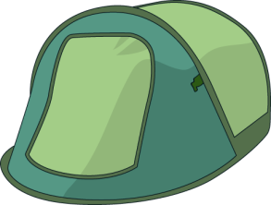

🞎 a map

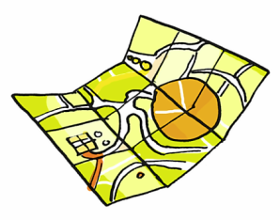

🞎 a mirror

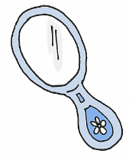

🞎 a sandwich

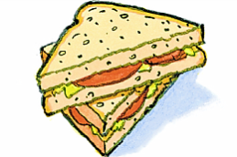

🞎 a bag

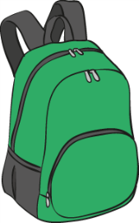

🞎 biscuits

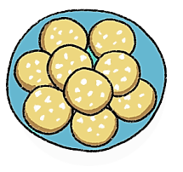

🞎 a bottle of water

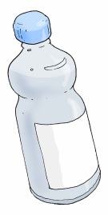

🞎 magazines





2. Compare with a partner. Choose the best three things. Write them down.

We must take

a) because .

b) because .

c) because .

3. Read page 9 and find out what the friends take with them.

|  |  |  |  |  |
| --- | --- | --- | --- | --- |
|  |  |  |  |  |
| D:\100_GESTALTUNGSBUERO\00_KLETT\09_548601_Online_Materialien_Lektuere_Ben\2019\Bilder_zu_KVs_Bat_Action_Time\S690548601_548601_012.png |  | D:\100_GESTALTUNGSBUERO\00_KLETT\09_548601_Online_Materialien_Lektuere_Ben\2019\Bilder_zu_KVs_Bat_Action_Time\S690548601_548601_012.png |  | D:\100_GESTALTUNGSBUERO\00_KLETT\09_548601_Online_Materialien_Lektuere_Ben\2019\Bilder_zu_KVs_Bat_Action_Time\S690548601_548601_012.png |
|  |  |  |  |  |

|  |  |  |  |  |  |
| --- | --- | --- | --- | --- | --- |
|  | Bat Action Time! - Lesebegleiter |  |  | Chapter 4 | 11 |
|  |  | | | | |

KV 6 The drain cover

1. Read page 10. Are the sentences right?

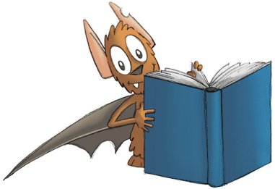

a) They flew to the drain cover together. 🞎 yes 🞎 no

b) It was warm outside. 🞎 yes 🞎 no

c) Ben took something out of his rucksack. 🞎 yes 🞎 no

d) Ben tried to open the drain cover. 🞎 yes 🞎 no

e) Ben and Izzy opened the drain cover. 🞎 yes 🞎 no

f) Izzy helped only a little. 🞎 yes 🞎 no

2. Read page 11. Are the sentences right?

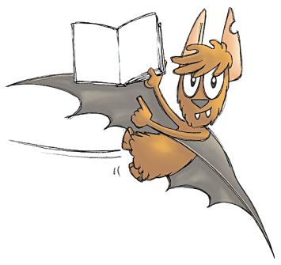

a) They did not open the drain cover. 🞎 yes 🞎 no

b) They heard friendly noises. 🞎 yes 🞎 no

c) The friends laughed. 🞎 yes 🞎 no

d) Toby ate something. 🞎 yes 🞎 no

e) Izzy wanted to eat something too. 🞎 yes 🞎 no

f) The friends flew down the dark hole. 🞎 yes 🞎 no

3. What was the scary noise? Who or what was under the drain cover?

Draw a picture.

|  |
| --- |
|  |

I think there was

|  |  |  |  |  |  |
| --- | --- | --- | --- | --- | --- |
|  | Bat Action Time! - Lesebegleiter |  |  | Chapters 1 – 4 | 11 |
|  |  | | | | |

KV 7 Revision: Storyline

1. Choose the right summary (Zusammenfassung) of chapters 1– 4.

A 🞎 Ben, Izzy and Toby were playing hide-and-seek at night. Then they saw a flashing light outside. A drain cover opened and they saw a green claw. Ben wanted to find out about the light. Ben packed the things for their adventure. Toby took a lot of food. The friends flew down onto the street. Izzy didn’t help a lot to open the drain cover. They heard strange noises and voices.

B 🞎 Ben, Izzy and Toby were playing hide-and-seek at night. Then Ben saw a flashing light outside. A drain cover opened and they saw a pink claw. Ben wanted to find out about the light. Ben packed the things for their adventure. Toby took a lot of food. The friends flew down onto the street. Izzy helped a lot to open the drain cover. They heard strange noises and voices.

C 🞎 Ben, Izzy and Toby were playing chess at night. Then they saw a flashing light outside. A drain cover opened and they saw a pink claw. Ben wanted to find out about the light. Ben packed the things for their adventure. Toby took a lot of food. The friends flew down onto the street. Izzy didn’t help a lot to open the drain cover. They heard strange noises and voices.

D 🞎 Ben, Izzy and Toby were playing hide-and-seek at night. Then Ben saw a flashing light outside. A drain cover opened and they saw a pink claw. Ben wanted to find out about the light. Ben packed the things for their adventure. Toby took a lot of food. The friends flew down onto the street. Izzy didn’t help a lot to open the drain cover. They heard strange noises and voices.



2. Write your own summary of chapters 1– 4. Make 4 mistakes. Can your partner find them?

\_

|  |  |  |  |  |  |
| --- | --- | --- | --- | --- | --- |
|  | Bat Action Time! - Lesebegleiter |  |  | Chapters 5 – 7 | 11 |
|  |  | | | | |

KV 8 In the tunnel – The shadow – Nyctalos’ secret

1. Read chapters 5-7. Tick the right answer.

Chapter 5

|  |  |  |  |
| --- | --- | --- | --- |
| a) … found the right tunnel.  b) The room at the end of the tunnel was ….  c) In the room, there were … bats. | 🞎 Ben  🞎 small  🞎 friendly | 🞎 Izzy  🞎 big  🞎 scary | 🞎 Toby  🞎 dirty  🞎 happy |

Chapter 6

|  |  |  |  |
| --- | --- | --- | --- |
| a) The big bat wanted to ….  b) Toby, Izzy and Ben suddenly saw ….  c) Toby coughed because …. | 🞎 control  the world  🞎 a door  🞎 Izzy   pushed him | 🞎 invite Ben   for tea  🞎 a light  🞎 he was ill | 🞎 kidnap  Toby  🞎 a shadow  🞎 he had a   muesli bar |

Chapter 7

|  |  |  |  |
| --- | --- | --- | --- |
| a) The bats wanted to … the friends.  b) Toby’s eyes became ….  c) Nyctalos was very …. | 🞎 help  🞎 green  🞎 kind | 🞎 kidnap  🞎 black  🞎 friendly | 🞎 play with  🞎 pink  🞎 evil |



2. Write an ending to the story. The ideas in the box can help you.

the police arrived • water went in • one of the bats helped the friends • they tied Nyctalos up •   
the friends asked someone to help with their plan • the friends got free • Nyctalos ran away • …

\_

3. Read the rest of the story. What is different?

|  |  |  |  |  |  |
| --- | --- | --- | --- | --- | --- |
|  | Bat Action Time! - Lesebegleiter |  |  | Chapters 8 – 10 | 11 |
|  |  | | | | |

KV 9 Ready for the fight – A strange party – The big surprise

1. Read chapters 8 – 10. Find the right order (Reihenfolge) of the sentences.

a) The friends got VIP backstage passes.

b) The friends saw lots of food on the tables.

c) The dance crew said “Sorry”.

d) A reporter thanked the ‘Bat Street Boys’.

e) The monsters shouted “Happy Halloween”.

f) The bat in the cloak freed the friends.

2. Ben tells some other friends about Nyctalos and the strange party. Correct his sentences.

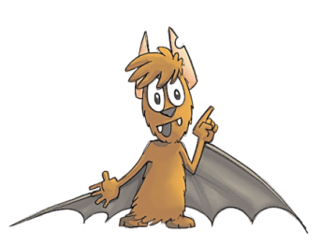

I thought the bats wanted   
to fight. But that wasn’t true:

Example:

“I thought that … But that wasn’t true:

a) the bats wanted to fight. They didn’t want to fight. They wanted to have a party.“

b) the bat in the cloak was evil. He was evil. He .”

c) my friends and I were kidnapped. .”

d) they ate normal food. .”

3. Did you like the story?

a) Colour the stars.

|  |  |
| --- | --- |
|  | story |
|  | pictures |
|  | characters (Figuren) |
|  | suspense (Spannung) |
|  | fun |



b) Write a short text and say why you liked / didn’t like the story.

|  |  |  |  |  |  |
| --- | --- | --- | --- | --- | --- |
|  | Bat Action Time! - Lesebegleiter |  |  | After you read | 11 |
|  |  | | | | |

KV 10 After you read

The three friends are very different. What type (Typ) of friend are you?

Answer the following questions. How many As, Bs, or Cs do you have?

|  |  |
| --- | --- |
| a) On a holiday, I like to …  B eat a big breakfast.  A read a good book.  C go shopping.  b) My favourite place in school is …  A the library.  AX  B  CX  ?  B the cafeteria.  C all clean rooms.  c) My friends say that I am …  C a bit posh.  B funny.  A clever.  d) On a trip, I take …  A a map, a torch and my rucksack.  B snacks and drinks.  C magazines and make-up. | e) For me it is most important that …  C my clothes are OK.  B teachers finish lessons before lunchbreak.  A we learn enough at school.  f) Trying new things is …  B too much work.  A great fun.  C OK, but new clothes are better.  g) When I am with friends, I …  C do what the others want to do.  A always have ideas for activities.  B am sometimes too tired to play.  h) In my room, there are …  C lots of clothes and fashion magazines.  B lots of sweets and a big bed.  A lots of books and games. |
|
|

|  |  |
| --- | --- |
| A |  |
| B |  |
| C |  |

|  |  |  |  |  |
| --- | --- | --- | --- | --- |
|  |  |  |  |  |
| D:\100_GESTALTUNGSBUERO\00_KLETT\09_548601_Online_Materialien_Lektuere_Ben\2019\Bilder_zu_KVs_Bat_Action_Time\S690548601_548601_012.png |  | D:\100_GESTALTUNGSBUERO\00_KLETT\09_548601_Online_Materialien_Lektuere_Ben\2019\Bilder_zu_KVs_Bat_Action_Time\S690548601_548601_012.png |  | D:\100_GESTALTUNGSBUERO\00_KLETT\09_548601_Online_Materialien_Lektuere_Ben\2019\Bilder_zu_KVs_Bat_Action_Time\S690548601_548601_012.png |
| Mostly A  You are **Ben**!  You like adventures and you need a lot of action. You don’t like to be quiet and you are always open for new things.  Sometimes your friends don’t like all your ideas, but they can always ask you for help. You like to try new activities and you really like good books. |  | Mostly B  You are **Toby**!  You love good food and you love your bed. You don’t like to walk fast and you hate stress.  Sometimes your friends are not happy because you are so slow, but you can always make them laugh! With you, it’s never boring. You don’t need friends with very good ideas for activities, you need friends who have snacks for you. |  | Mostly C  You are **Izzy**!  How you look – that’s important for you. You like to go shopping and you love to read fashion magazines.  Sometimes your friends are angry with you, but you are always there for them. You are organized and like to have everything clean. Someone needs a make-over? You are the one to ask! |